Consultation form
Name | Date of birth:
Address: | Gender: Height:  Smoker/Non-smoker. Weight:  Allergies:
Tel:
Email address:  Please read the ‘Informed consent and privacy statement’ on p.4 to confirm that you are aware how your personal data is used. | GP Name:  Practice address:
Emergency contact name:
Tel: | Tel:

Lifestyle
How much and what exercise do you do on a weekly basis?

List any complementary therapies you have had before?
Have you had any reaction afterwards?
Relief, reduced tension, aches, headaches, insomnia, increased urination
How would you describe your diet?
Healthy, regular meals, snacker, convenience meals
How much do you drink a day? | Water |  | Herbal/fruit tea:
Tea | Coffee | Juice/squash |  | Alcohol:
What is your job or what are the main activities you do on a daily basis?

Do you take any supplements?
Please list
Are you on any medication?
Please list

Medical history
Circulatory problems | High bp | Low bp | High cholesterol
 | Bruise easily | Varicose veins | Cold hands/feet
 | Thrombosis/DVT | Angina/heart problems
Details
Skin problems | Eczema | Psoriasis/Rosacea | Impetigo
 | Cuts | Scars/Burns
Details
Respiratory complaints | Hayfever | Asthma | Bronchitis
Nervous system disorders | Headaches | Migraines | MS/MD
 | Epilepsy | Parkinson’s | Numbness/Tingling  (where?)
Details
Urological considerations | Prostate | Gynae | Incontinence
Details
Obstetric history | Pregnant | C-Sections (No.) | Episiotomy
Details
Contagious disorders | Wart/Verrucas | Cold sores/Herpes | Athlete’s foot
 | Shingles | HIV | TB
Details
Emotional considerations | Depression | Bereavement | Stress/anxiety
Details
Other health problems | Surgery | Diabetes | Cancer
Details
Covid checks | Fatigue | Breathlessness | Palpitations
 | Persistent cough | Blood clotting issues | Gastro-intestinal issues
 | Vaccination None/Fully vaccinated | Smell/taste | Brain fog/Concentration difficulty
Details

Your treatment
Why are you here today?
Please list any injuries in chronological order. Any that have caused scars or surgery as a result should all be indicated on the attached musculoskeletal chart also.

Are there any movements that are painful and/or difficult for you to do?

Current pain levels:
☺ 1, 2, 3, 4, 5, 6, 7, 8, 9, 10 ☹
Current stress levels:
☺ 1, 2, 3, 4, 5, 6, 7, 8, 9, 10 ☹
What is it you want to achieve from the treatment? Is there a long term plan?

Musculoskeletal issues
Please indicate on chart below any areas of pain that you experience, eg osteoarthritis, back ache, muscle strains. Also use this chart to mark up any scars or old injuries that you have had. Examples are:
Head: dental implants, broken nose, concussion Neck: whiplash, cervical fusion, reduced movement
Shoulders: rotator cuff, impingement, frozen shoulder Arms and hands: broken bones, carpal tunnel
Trunk: broken ribs, belly button piercing Back: lumbar disc problems, sciatica, spondylolisthesis
Hips: impingement, partial/full hip replacement, Knee: pain, replacement, ligament damage
Legs: ITB, groin strain, breaks Ankle: sprain, pinned Feet: bunions, Morton’s neuroma, high or low arches
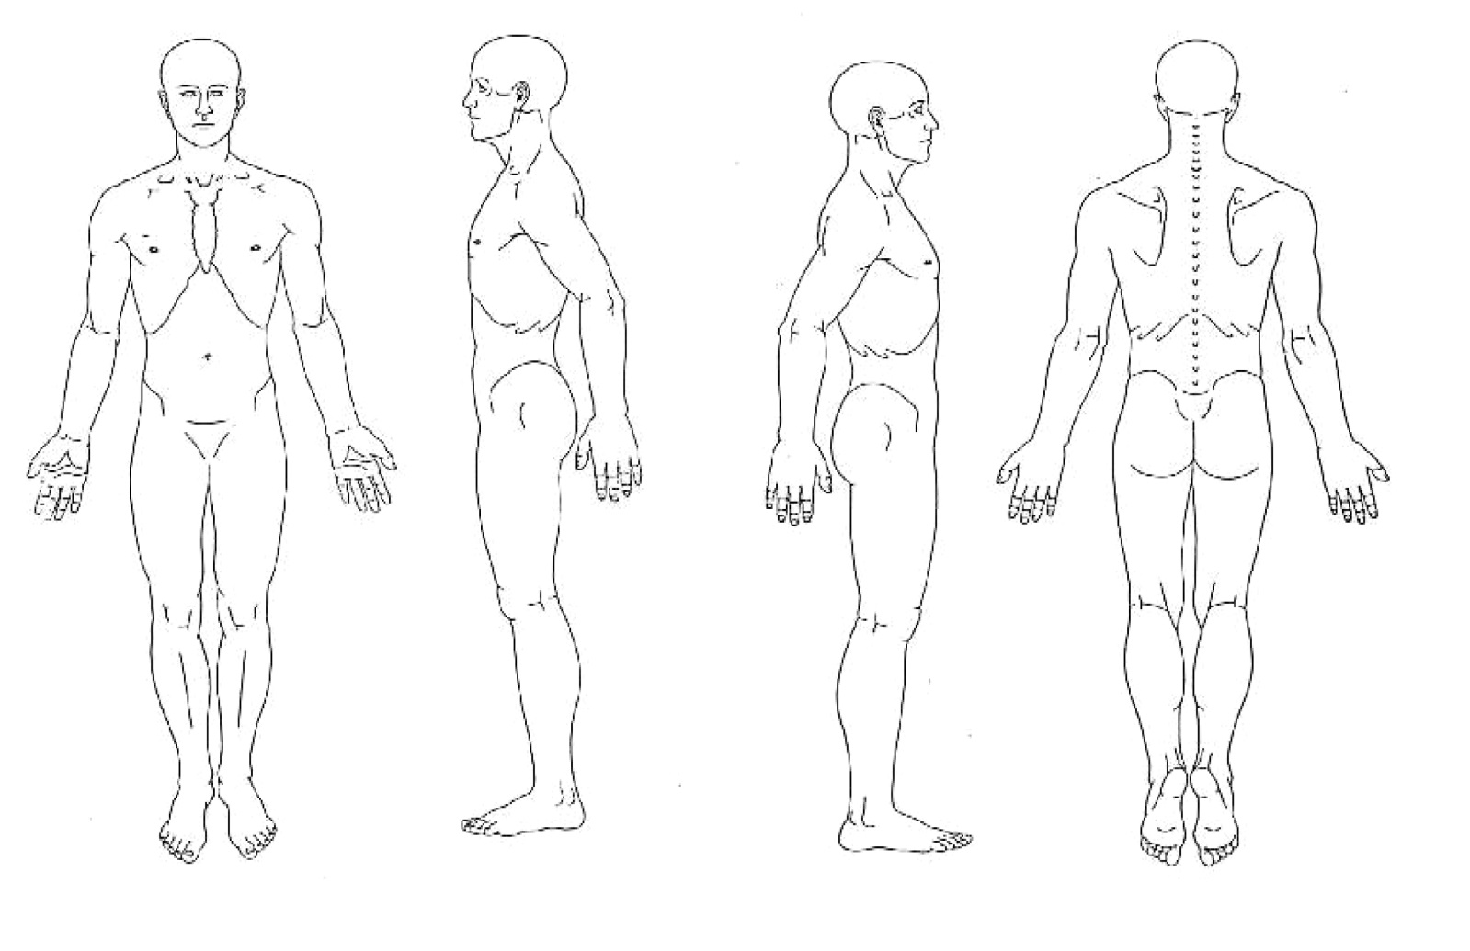
Treatment notes
SLS Perturbation
OA Flexion Extension Abduction Adduction IR ER LFl Rotation
AROM
PROM

RROM

Special orthopaedic tests:

Privacy statement
The data collected on this form will be used for the sole purpose of clinical massage and will not be disclosed to external sources unless legally required to do so. Your permission will be sought if a referral needs to be made to your GP or another health professional.
I agree: Yes / No
Sometimes during a treatment photographs or video is taken to help inform you, the client, for example to show your posture or gait analysis. Occasionally, this information is stored electronically in a cloud-based server and your name is not used to identify the images. Please confirm that you accept this.
I agree: Yes / No
Powertouch Therapy subscribes to some companies to support its business activities. For example, a company that supplies exercise information sheets is used because it allows exercises to be tailored to meet the needs of the individual and electronic notes are taken of appointments.
I agree: Yes / No
If you have any questions about the information and how it is used then please feel free to contact me in person, by phone (0759 050 1552) or by email: susan@powertouchtherapy.co.uk
I would love to sign up to your newsletter and be contacted with all your practice updates:

Informed consent
Massage is primarily the assessment and treatment of soft tissues to reduce stress and muscular tension. It is not a substitute for medical treatment or diagnosis, and a GP or other health professional should be seen for any physical or mental ailment you may be aware of. If you are currently receiving treatment by a GP, a health practitioner or other complementary practitioner please inform your therapist and continue to update her with any changes to your health profile.
If you do have any underlying medical conditions please confirm that you understand the treatment you are to receive and if you wish to consult with your GP or other practitioner prior to treatment then please do so. Some conditions where caution is required are: osteoporosis, inflamed nerves, acute rheumatism, psychotic conditions, trapped or pinched nerves, cancer, and any injuries that have occurred within the last 72 hours. If you are willing to proceed without contacting your GP or other practitioner you hereby indemnify the therapist against any adverse reaction as a result of the treatment.
Please note that treatment is always contra-indicated if you have a contagious or infectious disease, fever or under the influence of alcohol or drugs. In this new Covid-19 world please be aware that additional diligence is required. As always if you do arrive for an appointment and the therapist has any concerns about your health then they reserve the right to cancel the session without incurring any charge to you but you will have had a wasted journey so if in doubt please email/call to check in advance.
Please can you sign and date below:
Name: Email address: Date:

