Musculoskeletal issues
Please indicate on chart below any areas of pain that you experience, eg osteoarthritis, back ache, muscle strains. Also use this chart to mark up any scars or old injuries that you have had. Examples are:
Head: dental implants, broken nose, concussion Neck: whiplash, cervical fusion, reduced movement
Shoulders: rotator cuff, impingement, frozen shoulder Arms and hands: broken bones, carpal tunnel
Trunk: broken ribs, belly button piercing Back: lumbar disc problems, sciatica, spondylolisthesis
Hips: impingement, partial/full hip replacement, Knee: pain, replacement, ligament damage
Legs: ITB, groin strain, breaks Ankle: sprain, pinned Feet: bunions, Morton’s neuroma, high or low arches
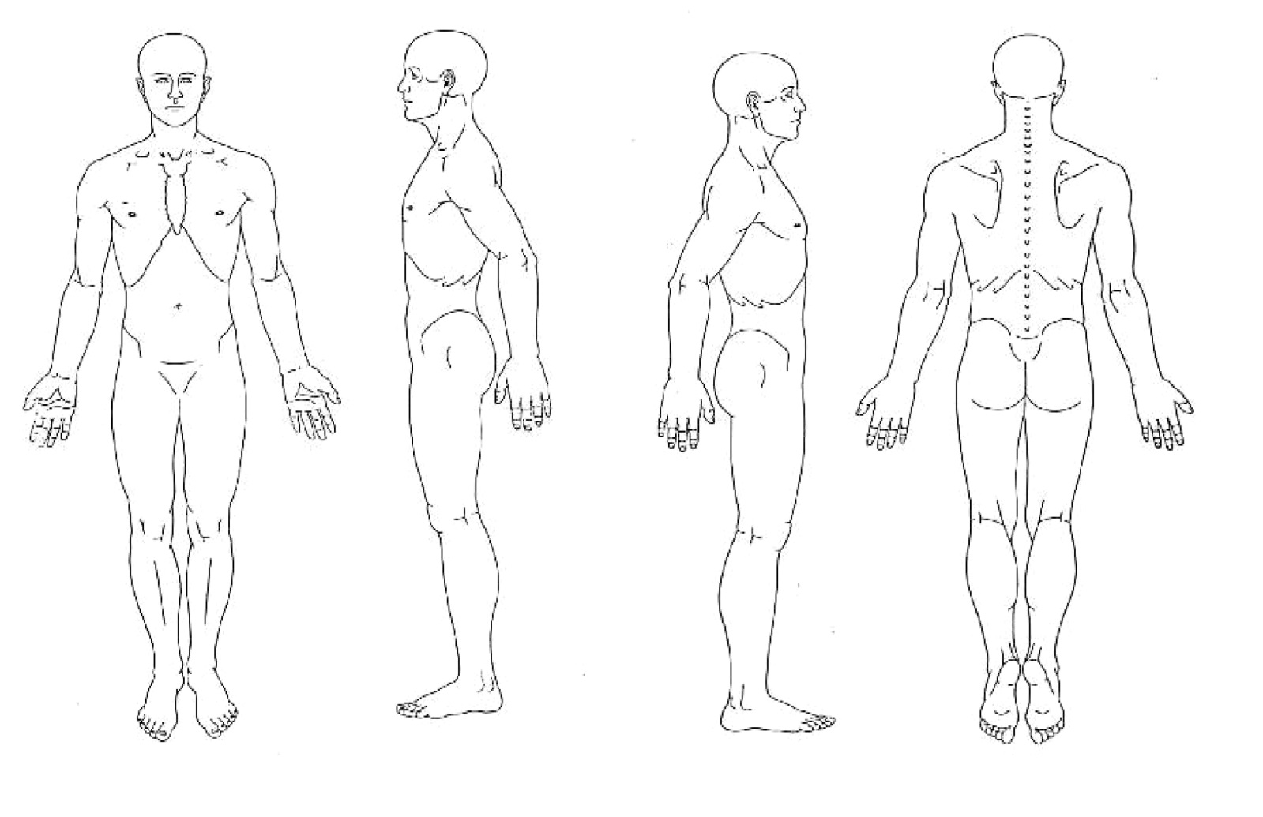
Additional comments:

